Rejuvenate Courts at Manor Park and Improve Accessibility 11/29/24
Sponsored by Boylston Parks and Recreation
Contact Alison LeBlanc
Manor Park, 10 Orient St Boylston 01505
CPA category:Recreation
Total Project Cost: $250,000
CPA Funds Requested: $93,000
Cost Share Amount: $157,000 from Boylston (96K of which requested from PARC Grant still in process)
Cost Share Percent: 36% CPA

Personnel: Project management to be included in the scope of the bid request. As the applicant, I will be working closely with Pamela Frechette, coordinator for Boylston Parks and Recreation, to ensure construction continues in a timely manner.
Equipment: nets, hoops, fencing, directed and timed lighting, signage, locks, AED machine, dumpster, signage indicating funding sources and court use rules, signage indicating parking/handicapped parking/drop off area
Supplies: 0
Contractual: project management, trash removal,
Construction: repaving tennis/pickleball court in existing footprint, resurfacing basketball court and replacing hoops, regrading walkway to ADA specifications using stone dust, replacing existing lights with directed lights on timers, removal of existing fences, acoustic fencing installed surrounding tennis courts
Other: 0
Total: 250k

Table of contents:
Page 3
- Detailed Project Description
- Responsible Parties
- Timeline
- Project Purpose
- Community Need
Page 4
- Community Support
- Budget
- Funding
- Feasibility
- Maintenance
- Project site documents
- Other information/Multiple Requests/Page Numbers
Page 5
- Chart of budget breakdown and CPA impact
Pages 6-7
- Photographs of existing court conditions
- Survey results from 2020 Boylston Open Space Committee indicting 45% of respondents would support general maintenance of existing courts
Page 8
- Diagram of proposed tennis and pickleball layout
- Inspiration picture of pickleball played on tennis court
Page 9
- Quote to estimate cost of tennis/pickleball court resurfacing, the portion of this project being requested before the Community Preservation Committee
- Detailed Project Description: This project aims to repave the existing tennis courts at Manor Park, lining the two double tennis courts to also accommodate four pickleball courts, re-seal and re-paint the existing full basketball court, create ADA accessible walkways from the street parking/drop off area, and signage added designating a parking area for the courts with an ADA space. Current lighting will be upgraded, addressing light pollution and environmental concerns. Current fencing surrounding the tennis courts will be upgraded to acoustic fencing, addressing noise reduction. Basketball hoops, tennis and pickleball nets will be replaced with modern equipment, addressing safety for players and ongoing equipment maintenance. An AED machine will be made available. A dumpster will be made available with a weekly trash removal contract to minimize litter.
- Responsible Parties: The Boylston Parks and Recreation Commission
- Timeline: Request for Proposals/bid process begins following approval at the May 2024 Boylston Town Meeting. Bid awarded July 2024, construction begins. Facility Inauguration June 2025
- Project Purpose: The purpose of this project is to provide safer and more accessible outdoor recreation for local pickleball, tennis and basketball enthusiasts of all abilities. Boylston currently lacks publicly-available outdoor tennis and pickleball facilities, despite a robust interest from local residents. Boylston currently has only one publicly-available updated outdoor full basketball court and it is heavily frequented. The current facilities at Manor Park are sadly outdated, not accessible for those with mobility concerns and represent a tripping hazard to players. The most recent maintenance was performed in 2000, almost a quarter century ago. The current parking for Manor Park lacks a handicapped parking area. Manor Park does not currently offer a dumpster with frequent trash removal in the court area, leading to frequent littering. Manor Park, enjoyed by baseball teams, dog walkers, families with young children, basketball players and soon-to-be tennis and pickleball players, does not currently offer an AED machine for emergencies. The lighting is not currently directed onto the courts and can only be turned on and off by Boylston Electric Department. It produces light that saturates the neighborhood, even when the courts are not in use. They will be replaced by energy efficient lighting, directed toward the high use areas and set on an automatic timer that can be controlled by players and by the parks department. The Parks Department will install locks and add signage indicating court use times to improve parking congestion and nighttime safety.
- Community Need: Boylston is an active community of all ages and abilities. The residents have often requested that the Parks Department make improvements to the area’s courts. The current condition of the courts at Manor Park present a significant safety hazard. Several new housing areas have been approved for construction by the planning board and the Parks Department aims to meet the needs of these new residents as well as provide recreation areas for our existing residents.
- Community Support: This project aligns with Boylston’s Open Space Plan, created through a resident survey process. Park abutters will benefit from the addition of noise reduction fencing, light pollution control and designated parking for various park uses. The Park Department will have the option to close and secure the courts when not in use, both for public safety and to improve parking availability. Differently-abled players will finally be able to access public tennis courts in Boylston. The rapidly-growing community of Boylston pickleball players will be able to recreate in town. Drainage in the area, particularly residential neighborhoods downhill, will not be affected by any additions proposed in the scope of this project, including the walkways. The pickleball community has frequently approached the Parks Commission with requests for outdoor court access. The Boylston Master Plan, created using feedback from resident surveys, outlines the public support for court and park improvements.
- Budget: tennis/pickleball 90K, basketball 60K, fencing and court striping for tennis/pickleball 58.5K, equipment 5.2K, safety and accessibility 36.3K, TOTAL 250K
- Funding: The funding will come from Community Preservation Act monies, and from the Town of Boylston pending approval by residents at town meeting. An additional PARC grant is being sought that aims to reimburse 60% of the cost of the project, to be returned to the Town of Boylston upon successful completion.
- Feasibility: The scope of this project does not include any changes to the footprint of the existing park features. The Parks Department will consult with Boylston Electric Department, Boylston Planning Board and Boylston Highway Department as needed throughout the project.
- Maintenance: The Boylston Parks and Recreation Department will provide any necessary ongoing maintenance, including trash removal and equipment. The hard surface is designed to create little to no maintenance within the first five years. As a reference, the basketball court at Center Park has required no maintenance in the seven years since its repaving.
- Project Site Documents:
- Other information: NA
- Multiple requests: NA
- Page numbers
- Attachments: photographs, inspiration pictures and overall park design
- 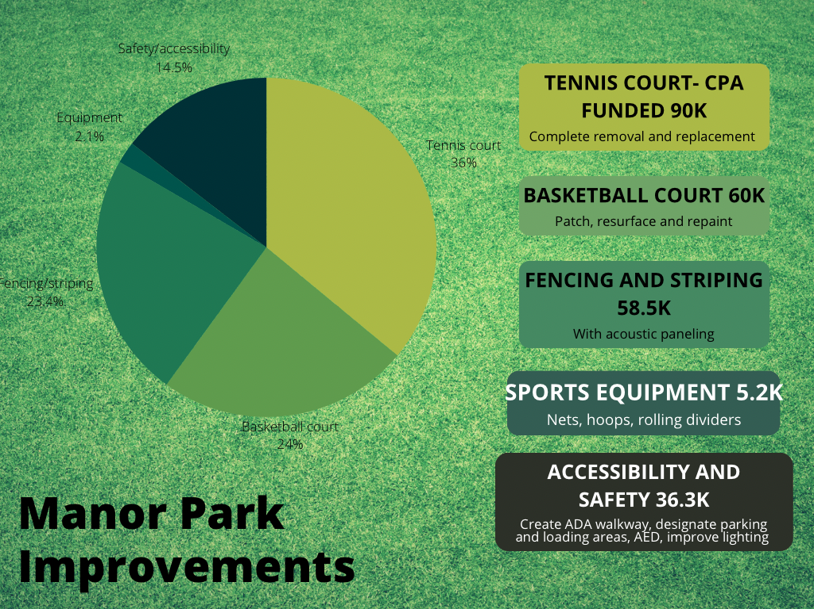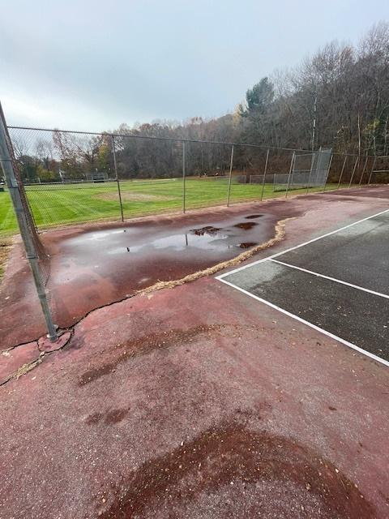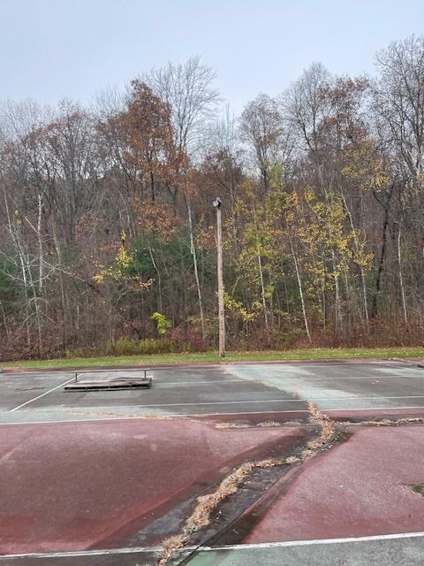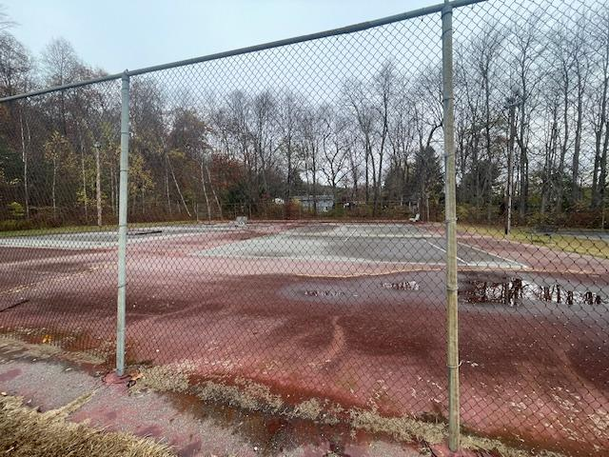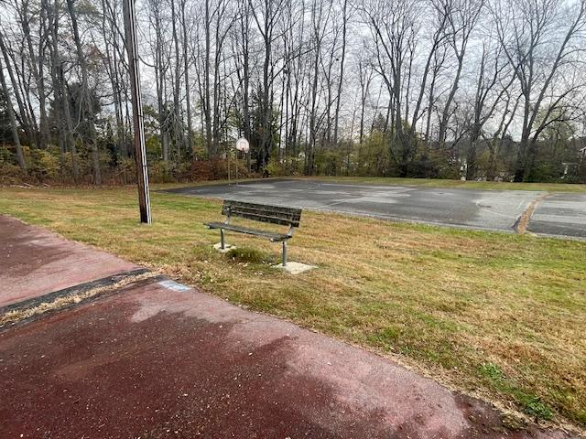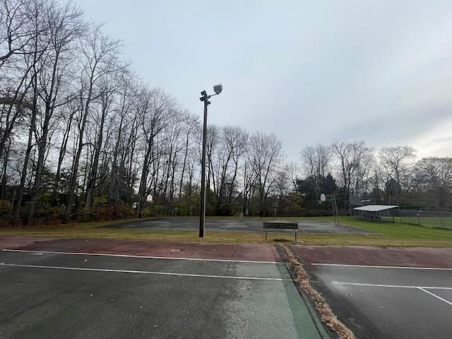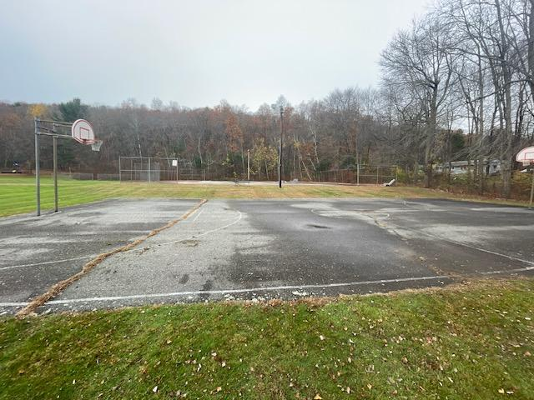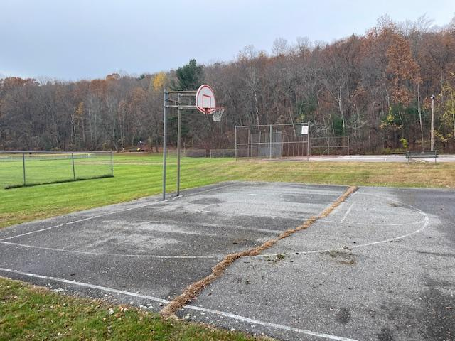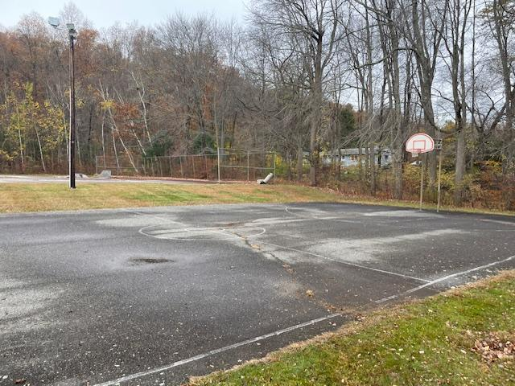This is from the Open Space Plan completed in 2020. NOTE the highest priority of the taxpayers surveyed was Increased General Maintenance of Existing Courts etc. 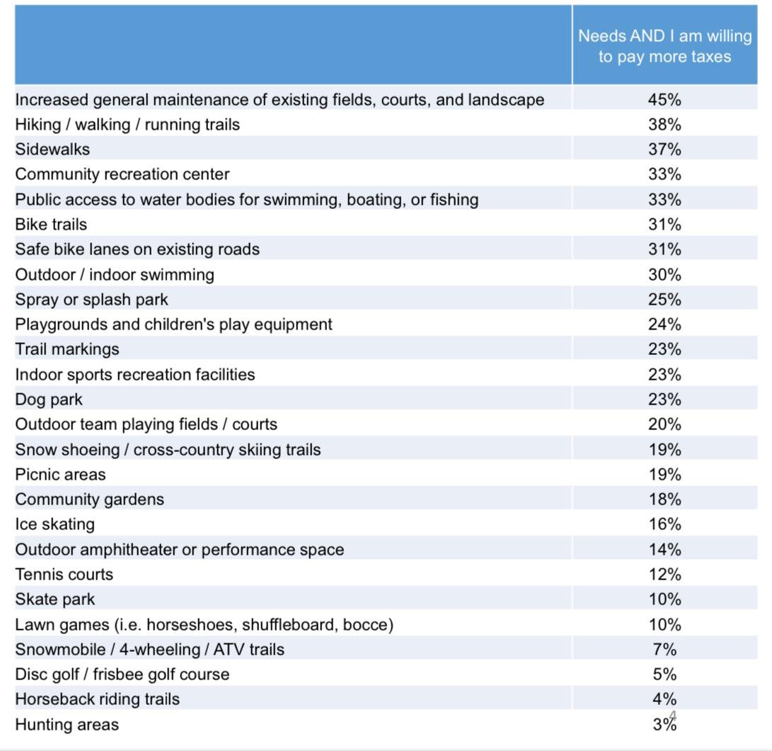
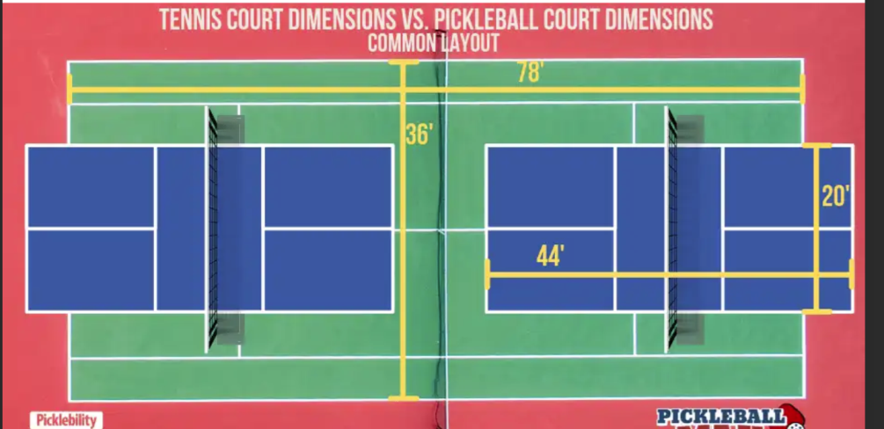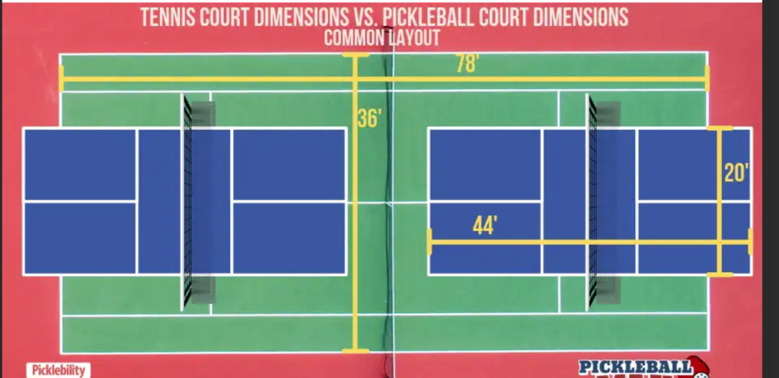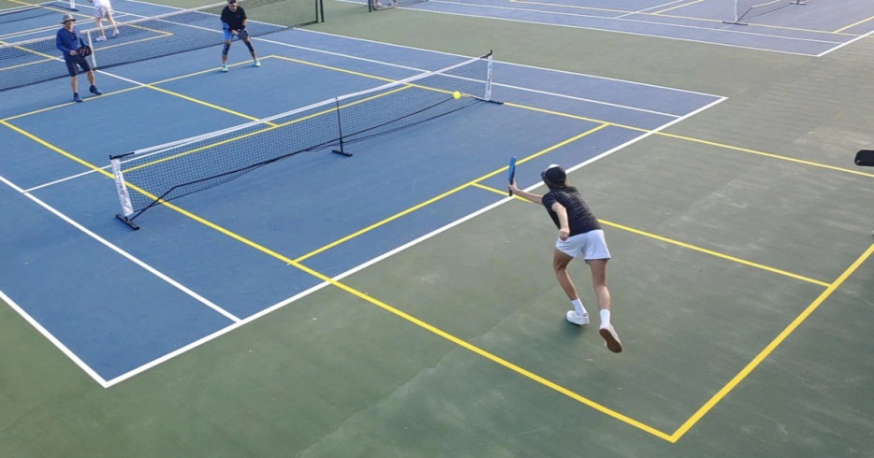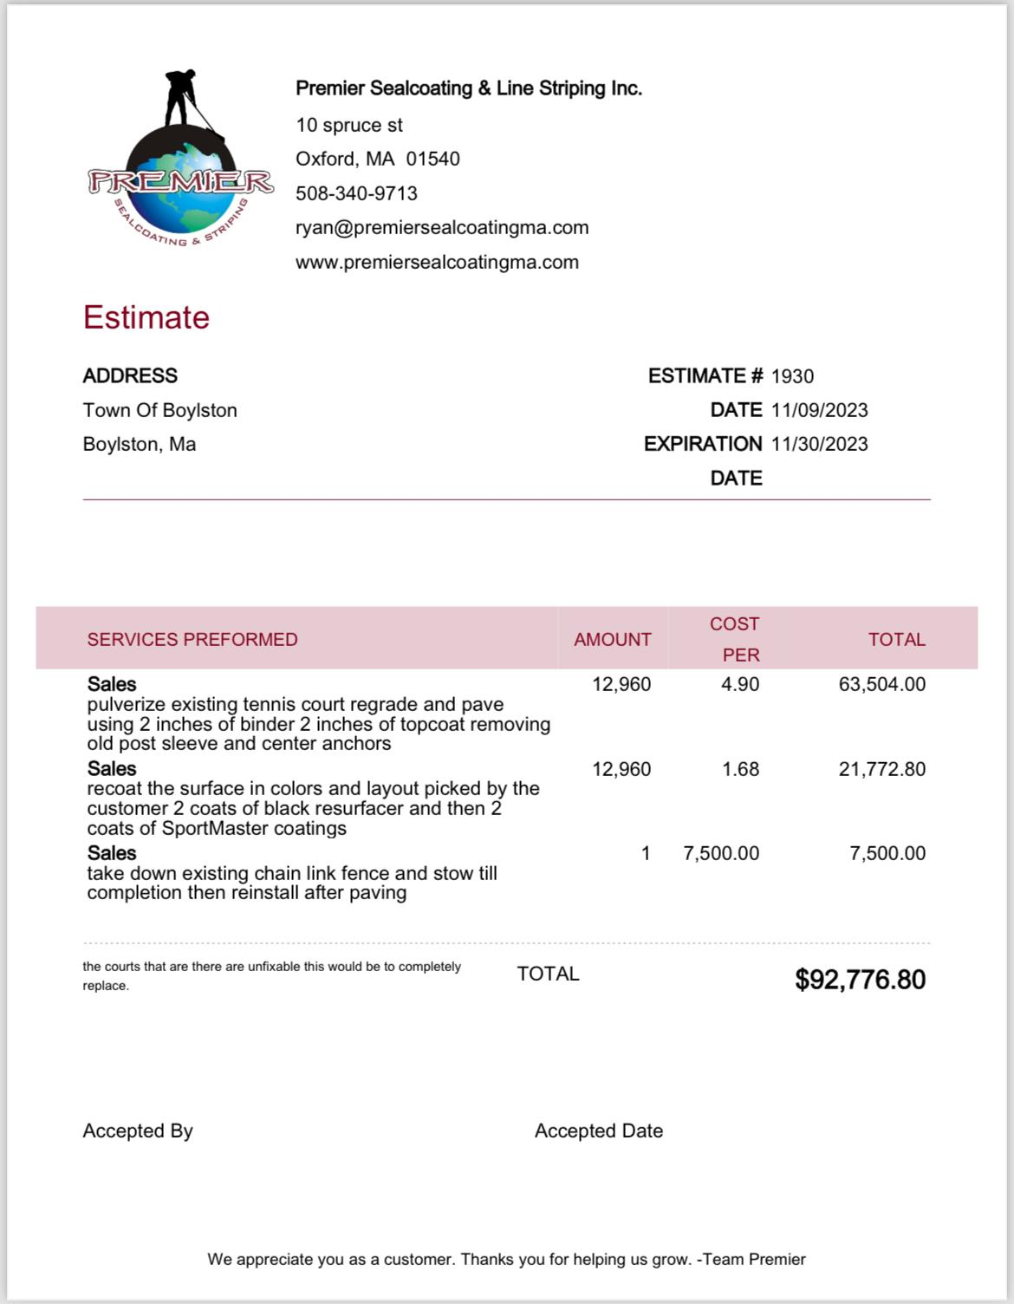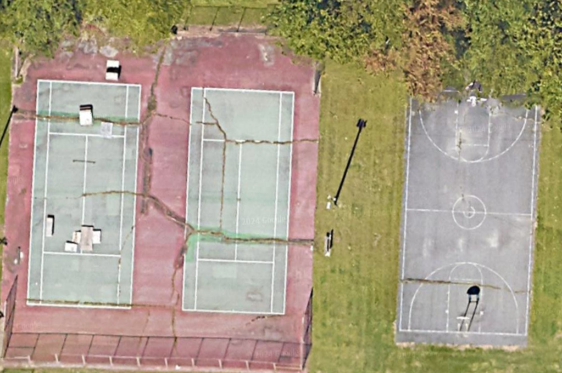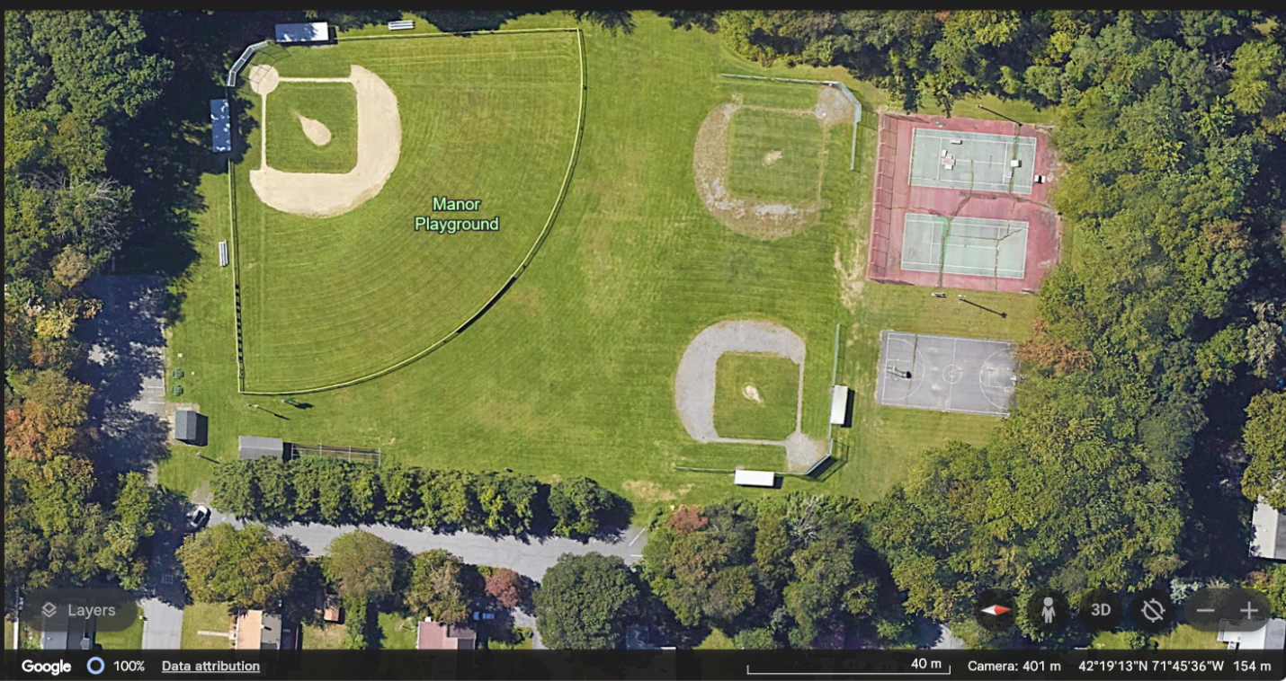

Letter of support to Boylston Parks & Recreation

As a citizen of Boylston I was asked to provide a brief letter regarding the funding for the Manor playground area. I have raised concern in the past and very appreciative of the actions taken already. The tree trimming and the removal of old termite wood around the play area, the added teather ball and the plastic play area.

The tennis and basketball courts are in need of updating. The option of new pickle ball court would be a great addition. This park is a great location and by having another playground that both parents and children can use together (similar to Hillside) would be a fantastic benefit to the town and people who live here. It would also be great if a new play structure could be added at some point so people don’t have to go to other towns to play. This update to the Manor will help people be outside and socialize with their families.

Thank you,
Karen Donoghue

Letter of support for adding much additional funding to our town’s Boylston Parks & Recreation department.

To: The Town of Boylston

I am writing as a resident of the town of Boylston. I have been lucky to live near Manor Park for decades. One of the many perks of living in this neighborhood is this park. It’s safe for the kids to walk/bike to. There are different sports fields available for use by our youth leagues and other residents. It’s a large area that makes great running spaces for our four-legged friends.
The one thing that is not so great is the lack of use on our courts over the past few years. Our youth baseball league (BYBSB), through hours and generosity of local volunteers and businesses, have been able to keep up with maintaining and upgrading our baseball fields. We have not been so lucky with our basketball courts. A perk of living so close to the park is hearing our neighbors use the basketball courts on a long summer evening. The sounds of the ball getting dribbled and the squeaks that come from a fun game of basketball travel all the way to my front steps. Seeing kids put down their electronic gadgets and be outside, enjoying a game of basketball with other kids. The sounds are fewer and farther between with the state our deteriorating courts are in. There is much repair needed to these courts due to cracks and outdated equipment to get our neighbors excited to play here.
Pickleball has also become a huge hit here in town. It is getting so popular; we need to put in some courts. Sadly, we don’t hardly have any space for this growing sport to play. A huge problem to have for a sport that has old and young alike playing together!
Our Commission of Parks and Recreation is looking for additional funds of their shoestring budget to help create safer and additional recreational spaces here in town. Their budget covers portable restroom rentals and very little else.
Please join the Commission of Parks and Recreation at our annual town meeting at Tahanto Regional High School in May and vote to add greatly need, additional funds to Parks and Recreation to give our outside facilities the help they need!
Thank you for your anticipated support!
Claudine Underwood
Boylston , MA

Quote included in attachments to justify the expected cost of tennis/pickleball court resurfacing

