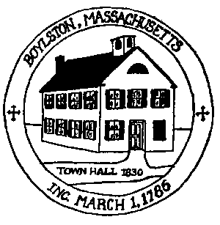
Da DRIVEWAY PERMIT
APPLICATION

Permit#:__________

P Date : ____________

TOWN OF BOYLSTON
Highway Department
(508) 869-2261

Address for Permit ______________________________________________________________________
Name of Property Owner _______________________________ Phone ________________________
Name of Applicant _________________________________ Phone ________________________
Contractor Name ___________________________________ Phone ________________________
Description of work ________________________________________________________________

All driveways hereinafter constructed or altered in the Town of Boylston must meet the following requirements and be viewed and signed (approved) by the Highway Superintendent before the driveway may be constructed or altered.
- The driveway shall not cause water, silt or other matter to discharge onto the public way.
- The driveway shall not restrict the flow of water along the side gutter of the public way.
- There shall be a safe sight distance for any vehicle to enter the public way.
- No driveway shall be constructed, reconstructed, or altered for a distance of twenty (20) feet from where it enters upon a public street with a grade exceeding ten percent (10%) slope.
- All driveway permits shall be issued in conformity with Town By-Laws.
A site plan and profile must be submitted with the application if it is a new driveway.
Permit must be picked up at the Highway department Office before paving begins.

Applicants Signature ______________________________________________________________________
Approved by Highway Superintendent ____________________________________________________

